Central Expressway Project – Section II

- Introduction
The “Central Expressway” from
Kadawatha to Dambulla and the Link Expressway
from Pothuhera to Galagedara with the Highway
Link to Ambepussa is the 4th Expressway which will
Connect major cites VIZ. Gampaha, Veyangoda,
Meerigama, Pothuhera, Kurunegala, Rideegama,
Melsiripura,Galewela, Dambulla, Rambukkana and
Galagedara. Interchanges will be constructed at
Kadawatha (System Interchange), Gampaha,
Veyangoda, Meerigama, Nakalagamuwa,
Potuhera (System Interchange), Dambokka, Rideegama,
Kurunegala, Melsiripura, Galewela, Dambulla,
Galagedara. System Interchanges provide
Connectivity only among expressways.
The access to expressway is provided only
at the Interchanges with appropriate Toll System.
The expressway has been divided into four sections for the purpose of construction as shown in the Table -1 below
Section No. | Name of Section | Length (km)
Section 01 | Kadawatha - Meerigama | 37.09
Section 02 | Meerigama - Kurunegala | 39.29
Section 03 | Pothuhera - Galagedara | 34.12
Section 04 | Kurunegala - Dambulla | 59.30
Table 01
- The Central Expressway- Section 2

Summary of the project

- Overall Length - 39.29km
- No of Interchanges - 4 including System IC
- No of Lanes - 4 ( Land acquisition is for 6 lanes – future expansion)
- Total Estimated Cost - LKR 137.34 bn
- Expected Land Acquisition Cost - LKR 8 Billion
- Construction Period - 30 month
- No of Contract Packages - 4
- Funding - Local Bank funds

The Central Expressway is a two way divided expressway with four lanes having hard shoulders and soft shoulders either side with a center median, interchanges and structures such as viaducts, bridges, culverts, under passes, overpasses etc. The Section II of the Expressway commences from Meerigama and proceeds up to Kurunegala with Ambepussa Link a total length equal to 39.29 km except Ambepussa Link. This Section comprises with Meerigama, Nakalagama, Dambokka and Kurunegala Interchanges. The design speed of the road is 100 km/hr. The whole trace of CEP-2 falls on a flat terrain.

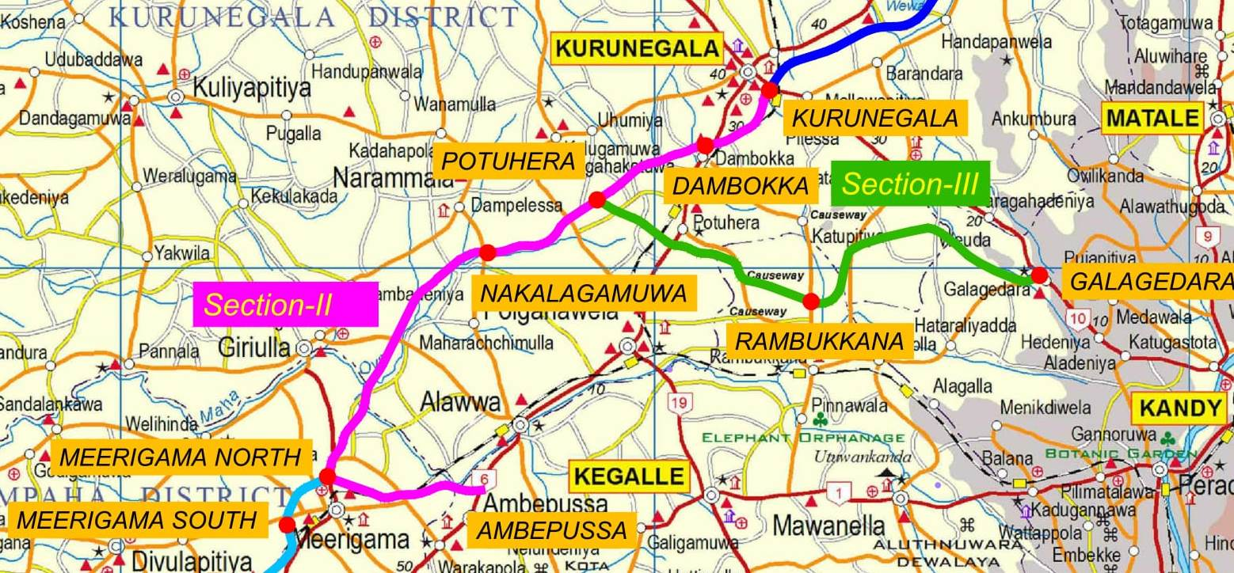

The total section of CEP-2 has been divided into 4 sections and each and every section has already been awarded to Contractor Consortiums shown in the table below. The Contractor Consortiums were selected from the Pre-qualified local Contractors.

 | Contractor Consortium | Package
1 | ICC-ACCESS-(NAWALOKA-KDESH JV) | PK-A
2 | SIERRA-OLYMPUS-(TUDAWE-CEC JV) | PK-B
3 | KDAW-NEM-E&C | PK-C
4 | MAGA, CML- MTD, (VVK-HOVEAL JV) | PK-D
Table - 2
The Table –3 provides the summary of details of Packages.

Package | Chainage |  | Length (m) | Location Name |  | Name Of Interchange (IC)
 | From | To |  | From | To
A | 37+090 | 46+800 | 9.71 | Meerigama | Riloluwa | Meerigama North
B | 46+800 | 57+000 | 10.20 | Riloluwa | Rangallepola (Narammala) | Nakalagamuwa
C | 57+000 | 62.330 | 5.33 | Rangallepola (Narammala) | Hiripathwala (Pothuhera) | Poyuhera ( System IC)
 | 63+900 | 69+500 | 5.55 | Dewatagedara | Maditiyawela
D | 69+500 | 78+000 | 8.50 | Ahugoda (Pothuhera) | Kurunegala | Boyagane & Kurunegala (Gettuwana)
Total |  |  | 39.29
Table -03

The following tables show the details of structures and interchanges.

Package | Viaduct/ m | Bridge/m | No of Box Culverts | No of Underpass box
A | 1830 | 160 | 22 | 2
B | 1730 | 200 | 31 | 3
C | 570 | 210 | 37 | 3
D | 821 | 100 | 31 | 7
Total | 4,951 | 670 | 121 | 15

Table-04

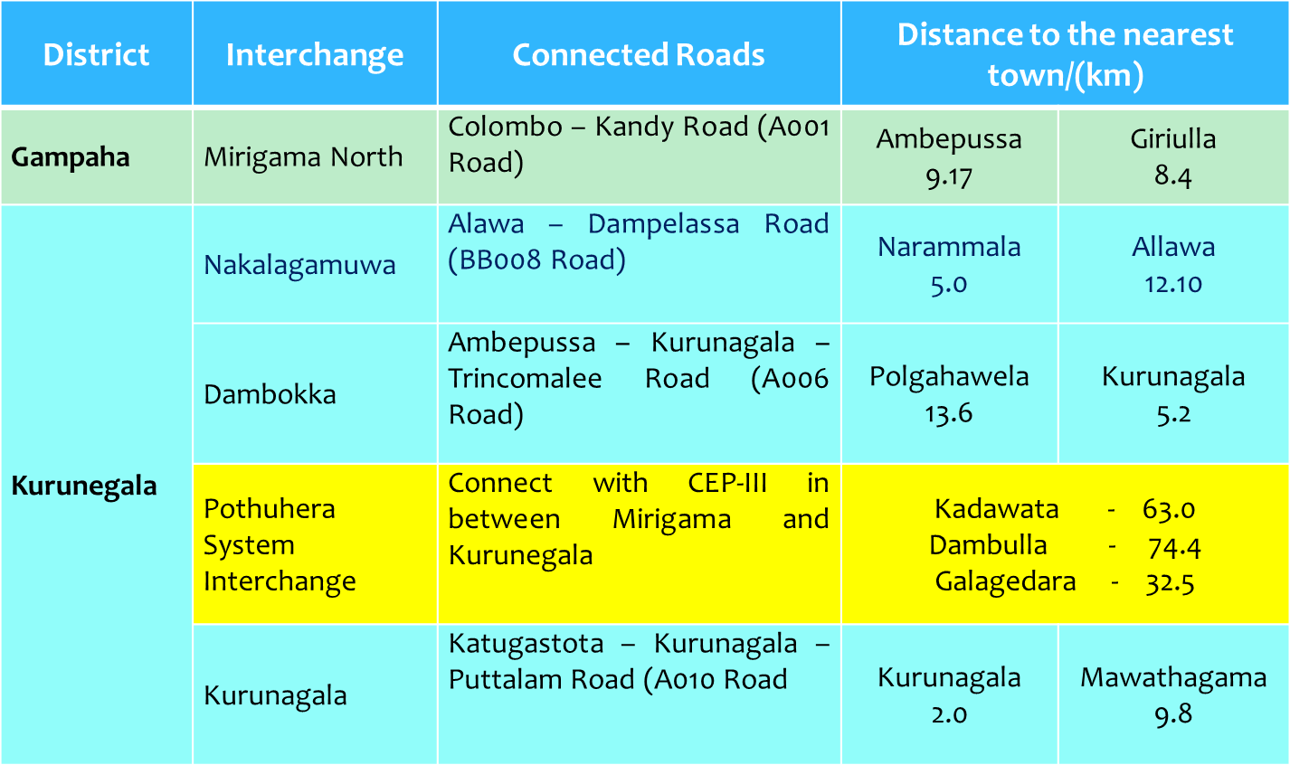

Table - 05
The Contractors shall carry out detailed structural designs based on the conceptual designs prepared by the Road Development Authority.

- Details of Property Damages

District | DS Division | Total No of Lots To be acquired | Paddy fields | Garden (Private) | Garden (Estate) | Roads, Streams & Canals | No of Houses affected
Gampaha | Meerigama | 48.9762 | 29.9662 | 14.748 | 0 | 4.262 | 36
Kurunegala | Allawwa | 42.0173 | 12.3514 | 22.8257 | 2.5405 | 4.2998 | 6
 | Narammala | 92.2433 | 33.5517 | 54.8836 | 2.9518 | 6.6857 | 50
 | Polgahawela | 44.6191 | 21.471 | 20.4711 | 0 | 3.4475 | 13
 | Weerambugedara | 32.8574 | 8.5639 | 22.688 | 0 | 1.6055 | 34
 | Kurunegala | 84.3263 | 33.7344 | 46.4193 | 0 | 4.1726 | 53
Table - 06

- Method of Project Implementation

The supervision part of CEP –II Project has also been awarded to a single Local Consultancy Consortium by grouping Consultancy Firms from short listed firms under FIDIC Conditions of Contract - 1999 Edition – Red book with “Quality Control” quality assurance system. The Consultancy service of MGC-ECL-RDC JV in association with CEA, CECB, OCYANA and Green Tech Consortium shall supervise, administer and monitor the all project activities. The project will be implemented on the basis of admeasurement type contract.

- Financing
Local Banks operating in Sri Lanka have accepted to fund the project (Civil works aswell as Consultancy).
The Accepted Contract Amount (Civil Works) – LKR 137.24 Billion

- Responsibilities of RDA

- Acquiring of lands within the proposed right of way (ROW)
- Coordinate with District Secretaries in the process of land acquisition
- Coordinate with Survey Department in the process of preparation of Advance tracings / Preliminary Plans etc.
- Monitoring progress of land acquisition
- Conducting awareness programmes among affected parties to educate affected people regarding compensation paid to affected lands, LARC and super LARC meetings and to address the issues raised by public
- Identify social problems and flood affected areas etc.
- Conducting LARC / Super LARC meetings
- Liaise with Design office to sort out design issues in finalizing designs
- Attending District /Divisional Coordinating Committee meetings and other special meetings conducted by political leadership
- Preparing BOQ /Procurement Plan / Bidding Documents for procurement of Contractors
- Bid Evaluation and Preparing TEC Report
- Preparing TOR for Consultancy Procurement
- Conducting Pre bid meetings
- Evaluation of Proposals and Selection of Consultant
- Attending Technical Evaluation Committee meetings and Cabinet Appointed Negotiation Committee meetings and preparing meeting minutes
- Preparing Resettlement Plan
- Payment of Compensation for affected parties
- Attending public complaints
- Assist in administration and management of civil work contract and consultancy contract and when problems arise
- Assign counterpart personnel and staff for the purpose of liaison with the other Government Agencies.

- Details of RDA Staff

- Project Office (Head Office)

- Project Director
- Deputy Project Director
- Procurement Consultant
- Project Accountant
- Administrative Officer
- Account Assistant
- Management Assistant (03 Nos)
- Typist (01)
- Office Aid (03 Nos)
- Drivers (02Nos)

- Project Sub Office (Kurunegala)
- Deputy Project Director
- Project Engineers (03 Nos)
- Land Consultants (04 Nos)
- Administrative Officer
- Development Officers ( 05Nos)
- Resettlement Assistants ( 02 Nos)
- Technical Assistants (03 Nos.)
- Management Assistant (03Nos)
- Office Aid
- Drivers (02Nos)

- Progress of Activities during the year 2016

Land Acquisition

No | Description | Total Length | Length -completed (km) | Progress (%)
1 | Section 38a order | 40.91km | 39.02 | 95%
2 | Section 38a Gazette |  | 39.02 | 95%
3 | Section 5 Order |  | 37.47 | 92%
4 | Section 5 Gazette |  | 29.58 | 72%
5 | P-Plan |  | 25.43 | 62%
6 | Section 7 Gazette |  | 11.89 | 29%
Description |  |  | No. of Lots Completed | Progress (%)
7 | Section 9 Inquires | 3779 Lots | 197 | 5%
8 | Section 10(1) Decision -Sent to Valuation Department |  | 164 | 4%
9 | Section 17 -Received from Valuation Department |  | 108 | 3%
10 | Conducting LARC |  | 105 | 3%

Table – 07

Progress of Preliminary activities

Item | Description | Progress | Remarks
1 | Feasibility Study | Amalgamation of two feasibility studies (CKAH&NEP) has completed and report will be read by 31.01.2016 | University of Moratuwa
2 | Topographical surveying | Completed
3 | Environment Impact Assessments (EIA) | CEA requires to have one EIA report incorporating previous studies & it is in progress will be completed and submitted Draft report by 31.01.2016 and expected approval by CEA before End of March 2016 | University of Sri Jayewardenepura
4 | Resettlement Action Plan | Preparation of RAP for the ADB section by Individual Consultant has submitted Draft report last month and ESD has given comments to be incorporated and final report submitted and forwarded to ADB already for reviews. | Needed by Funding Agency. But
5 | Bore hole investigations | Completed for preliminary designs and  Detailed Bore hole Investigations will be completed by end of 2016 | More investigations are to be done for Detailed designs by the Contractors
6 | Hydrology study | A comprehensive Hydrology study has been carried out for Detailed Designs to be completed by SLLRDC | Sri Lanka Land Reclamation & Development Corporation (SLLRDC)
7 | Preliminary designs | Completed | Highway Design Office, RDA
8 | Land Acquisition | In progress (60%)
9 | Selection of Supervision Consultant | Completed
10 | Topographical surveying | Completed
11 | Bidding | Completed
12 | Bid Evaluation | Completed
13 | CANC Approval | Approved
14 | Cabinet Approval | Approved
15 | Tender Awarding | Awarded

Table - 8

Financial Progress

Road Section | Length  /km | TEC (LKR) | Date of Commencement | Anticipated date of completion | Progress up to 2015 | Expenditure up to 2015 | Progress as at end of 2016 | Expenditure during the year 2016
37.09 To 78.00km | 39.29 | 137.34 | 16.01.2017 | 15.07.2019

Table – 9

- Constraints to Progress and the remedial action

Delays from Divisional Secretariat offices affect the land acquisition progress. Full time assistance is provided by RDA to minimize delays.

